Chess'N'Chat

Team members:

Adigun Jide Idris 7128525

Chenglong Zhang 6842666

Kun Wang 6713084

Pavithra Keshavamurthy 6827527

Sun liu 6758878

Due: Jan 17th, 2 marks

We have compiled and assessed this project a believe it to be of a reasonable size for a term project.

Chenglong Zhang

Pavithra Keshavamurthy

孙柳

Kun Wang

Adigun Jide Idris

# Project Description

Chess is a two-player [strategy](http://en.wikipedia.org/wiki/Abstract_strategy_game) [board game](http://en.wikipedia.org/wiki/Board_game) played on a [chessboard](http://en.wikipedia.org/wiki/Chessboard), a checkered game board with 64 squares arranged in an eight-by-eight grid. This is one of the most popular games played by millions of people. You can read the User Manual in the game if you click the help.

The game involves certain rules to be followed when playing. There are about sixteen characters involved in this chess game; one [king](http://en.wikipedia.org/wiki/King_%28chess%29), one [queen](http://en.wikipedia.org/wiki/Queen_%28chess%29), two [rooks](http://en.wikipedia.org/wiki/Rook_%28chess%29), two [knights](http://en.wikipedia.org/wiki/Knight_%28chess%29), two [bishops](http://en.wikipedia.org/wiki/Bishop_%28chess%29), and eight [pawns](http://en.wikipedia.org/wiki/Pawn_%28chess%29). Each of the six piece types [moves](http://en.wikipedia.org/wiki/Chess#Movement) differently. Pieces are used to attack and capture the opponent's pieces, with the objective to '[checkmate](http://en.wikipedia.org/wiki/Checkmate)' the opponent's king by placing it under a threat of capture. In addition to checkmate, the game can be won by the voluntary [resignation](http://en.wikipedia.org/wiki/Resign) of the opponent, which typically occurs when too much [material](http://en.wikipedia.org/wiki/Material_%28chess%29) is lost, or if checkmate appears unavoidable. The game also involves a draw where neither player 1 nor player 2 wins. The course of the game is divided into three phases: [opening](http://en.wikipedia.org/wiki/Chess_opening),

The project domain is particularly of interest to us because of the amount of functionality it provides; as mentioned above: it allows users (two players) to play chess game online or locally and also provides additional functionality of chatting to other user whilst playing. The system also tracks and records every move made my both user, it also provides thirty two smiles to capture how each player feels about a particular event that occurs during the gameplay, with every possible emotion provided for. This level of functionalities shows how intricate and complex the system is, hence the reason why we chose this project.

This project is an open source project, and basically it is a game which is written in java and it implements multiple functionality of a basic chess online game, it can be compiled and tested on eclipse. It is a stable project. The current release of the project is in 2011. There are two developers working on this project.

# Project Size and Scope

We used google code pro to count lines of code for each class.

The entire project consists of about 8000 Lines of Code (LOC) among 68 classes. We see this as medium sized project which would facilitates in understanding the business logic and give us an opportunity to refactor the source code by applying design patterns.

We found that Comments Ratio is estimated to be about 8.7% of the total lines of code. This will help us in understanding the business logic of the code.

We consider that the project selected is a good candidate to be considered as a term project because at first it facilitates us to understand the control flow the source code of the game from one class/package to another. This helps us in understanding the complete system architecture of this game and also interests us in understanding the domain.

Using the google code pro analyze the code and generate the overall result of the program.it contains the lines of code (almost 8000 lines), number of the methods, etc.

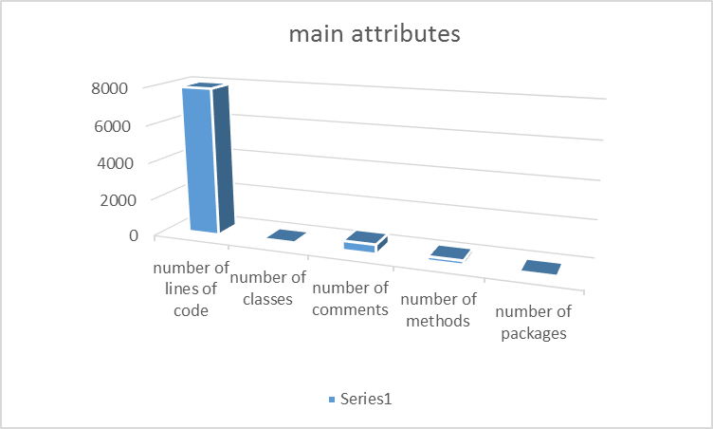

# Group Members

|  |  |
| --- | --- |
| **Team members** | **Details of contributions** |
| Sun liu | Participated in selecting source code, Rational for selecting project, project description and communicate with team members |
| Kun Wang | Project selection, analyze the code, communicate with the team |
| Chenglong Zhang | Make plans of the whole project, analyze the code, write documents about the system and communicate with team members. And |
| Pavithra Keshavamurthy | Make decision about project and its motive, and communicate with team members, analyzing of project code and its internal working , gather requirements and prepare documentation about the system |
| Adigun Jide Idris | Project selection, team communication, code analysis, planning and documentation. |

**Chenglong zhang**

I am familiar with the object orient language especially C# and java, and I used to do some development projects in my intern. I have some experience working with the open source software through some course projects. I have considerably strong knowledge of the refactoring. So, I definitely can provide support in that aspect.

**Pavithra Keshavamurthy**

Working on a Java makes me feel comfortable. I have experience in working and developing middleware tools like webmethods and edi manager which involves java at the backend. My recent project was built in Java. This understanding of how Java projects will help me understand the coding standards which can lead to some refactoring strategies. Further, it can help me understand the use of this gaming application. It was a great experience obtaining this project as a candidate. I am familiar with Java programming language and would give my best to understand the complete system architecture of this project.

**Adigun Jide Idris**

I majored in Software Engineering in my college years. My experiences in java programming language and software analysis, design and architecture during this time put me in a very good position to play an important role in this team. Since the project we are working on is built entirely on java and it's object oriented which speaks of an original and well thought of design quality the creator had in mind. However, I hope to apply my experience over the years to redesign and hopefully improve the program design and of course maintaining the original external behavior of the system.

**Kun Wang**

I am familiar with Java. I’ve developed some programs using java before like “Student Record System”, “Bomb man game” and so on. And so did I learn some refactoring knowledge in the past lectures I’ve taken. No doubt I’ll try my best to do some help in understanding the project we’ve chosen, and make my contribution in this team.

**Sun liu**

I am familiar with java and I have some experience developing some systems using java language with my teammates, last semester, me and my classmates, we worked really well on a java banking system, it was really a lot of fun when worked with someone on a big project, and this can also help me improve my java programming skill, I also know something about html5, and c#, etc.